 **Mumbai University**

**TPCT’s, TERNA ENGINEERING COLLEGE (TEC), NAVI MUMBAI**

**UG PROGRAM IN COMPUTER ENGINEERING**

**SUBMISSION REPORT FH 2021**

**Subject: Software Engineering (SE)**

**Class: TE (B)**

**Name of student: AMEY THAKUR**

**College ID: TU3F1819127**

**Roll No: 50**

**INDEX**

|  |  |  |
| --- | --- | --- |
| **Sr.No** | **Particulars** | **Submitted/Not Submitted or Enter Marks received** |
| **Experiments** | | |
| **1** | Prepare a detailed problem statement for the selected mini project and identify a suitable process model for the same with justification. | 9/10 |
| **2** | To prepare software Requirement Specification document(in IEEE format) for the selected mini-project. | 9/10 |
| **3** | Draw DFD (up to 2 levels) and prepare Data Dictionary for the project. | 9/10 |
| **4** | Identify scenarios & develop a UML Use case for the selected mini-project. | 9/10 |
| **5** | Develop a UML Class Diagram for the selected mini-project. | 9/10 |
| **6** | Develop Sequence and Collaboration diagram for the selected mini-project. | 9/10 |
| **7** | Develop Activity / State Transition diagram for the selected mini-project. | 9/10 |
| **8** | Study the project management tool and schedule project plan using any tool (Gantt Chart, Critical Path Method, and Earn Value Analysis). | 9/10 |
| **9** | Estimation of project metrics using COCOMO. | 10/10 |
| **10** | Design User Interface for the selected mini-project. | 9/10 |
| **11** | To prepare RMMM Plan for the selected mini-project. | 9/10 |
| **12** | Perform white box and black box testing and Develop test cases for same. | 9/10 |
| **Assignments** | | |
| **13** | Assignment No 1 | 9/10 |
| **14** | Assignment No 2 | 10/10 |
| **15** | Assignment No 3 | 9/10 |
| **Quizzes** | | |
| **16** | SE Quiz 1_Chapter 1 | 10/10 |
| **17** | SE Quiz 1_Chapter 2 | 10/10 |
| **18** | SE Quiz 1_Chapter 3 | 10/10 |
| **19** | SE Quiz 1_Chapter 4 | 10/10 |
| **20** | SE Quiz 1_Chapter 5 | 10/10 |
| **21** | SE Quiz 1_Chapter 6 | 10/10 |
| **IAT** | | |
| **22** | IAT-1 | 19/20 |
| **23** | IAT-2 | Submitted |
| **Exit Survey** | | |
| **24** | Course Exit Survey | Submitted |
| **25** | Laboratory Exit Survey | Submitted |

**Signature:**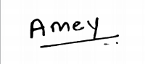

**Experiments**

**Software Engineering Experiment 1**

**Marks: (9/10)**

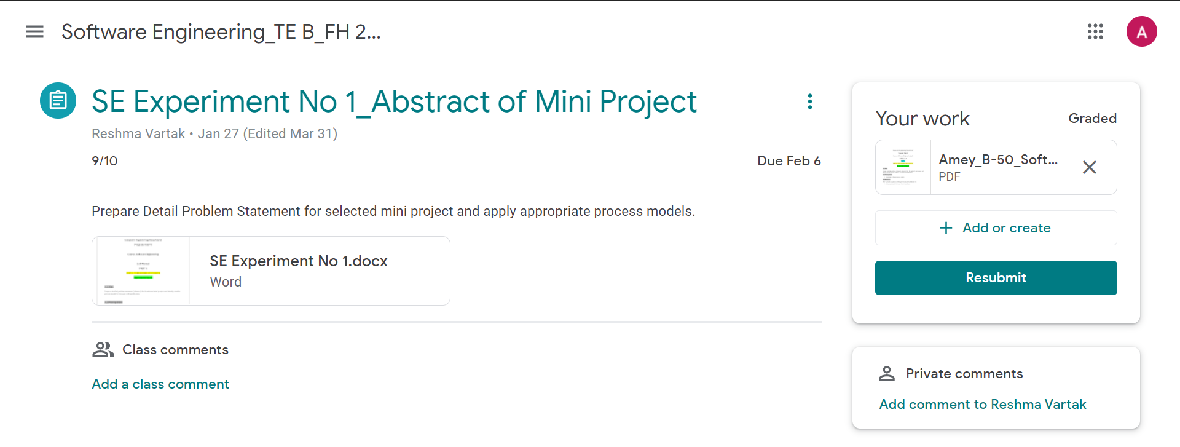

**Software Engineering Experiment 2**

**Marks: (9/10)**

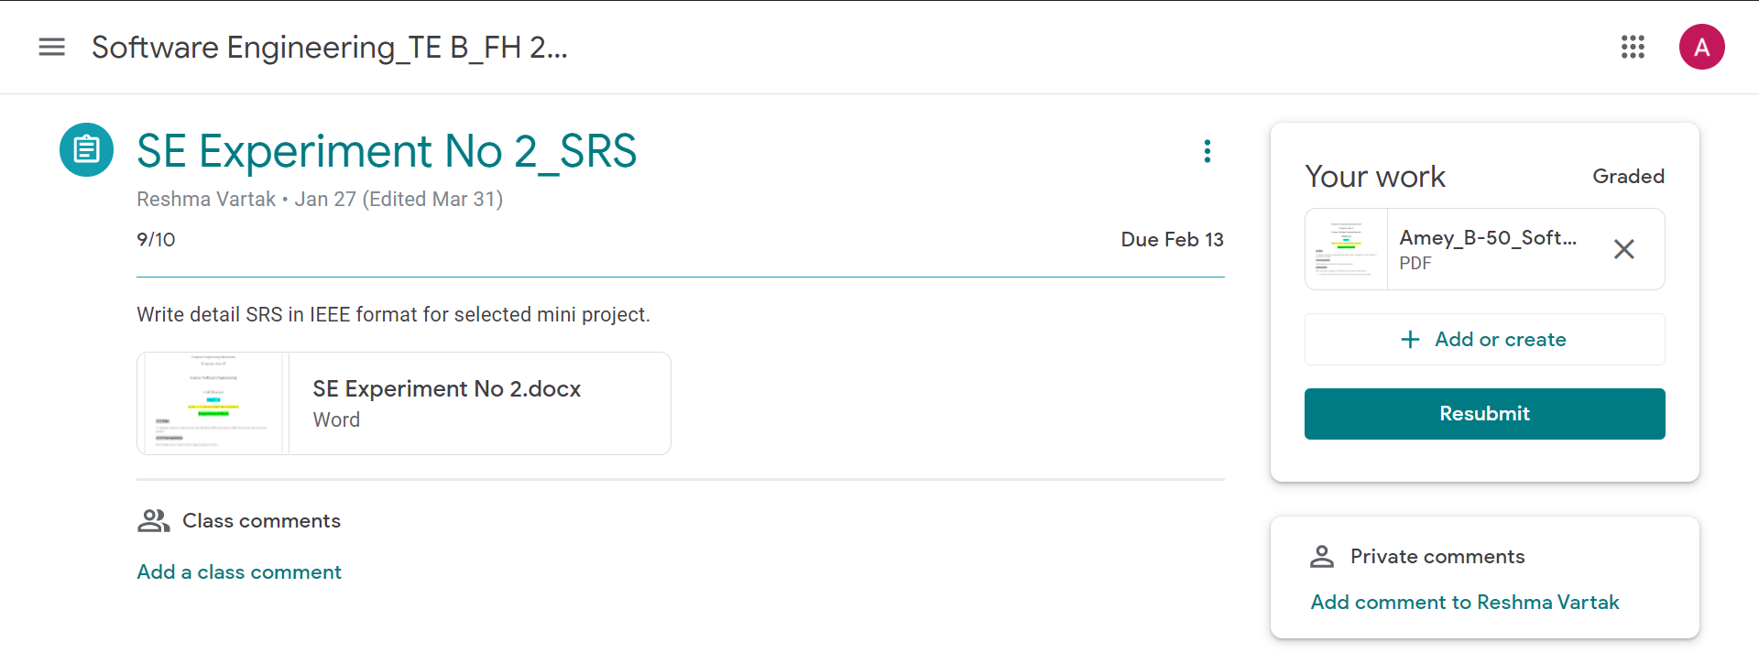

**Software Engineering Experiment 3**

**Marks: (9/10)**

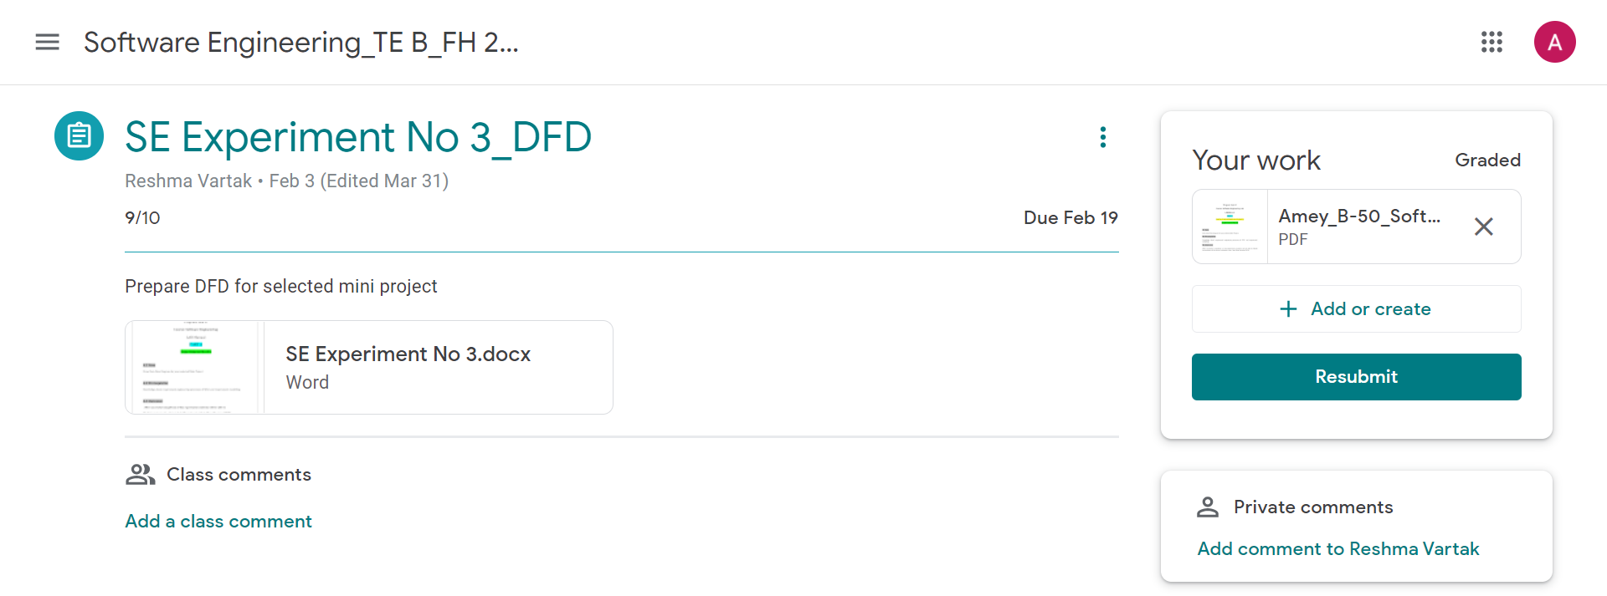

**Software Engineering Experiment 4**

**Marks: (9/10)**

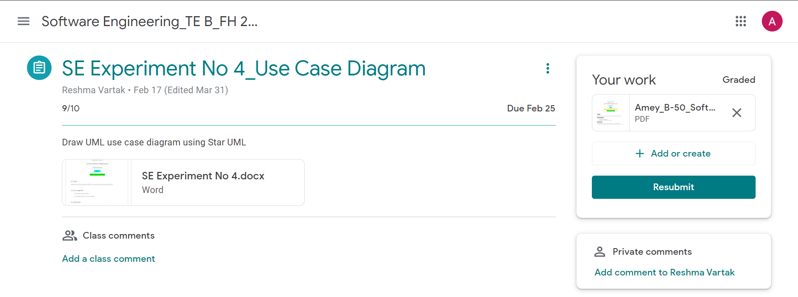

**Software Engineering Experiment 5**

**Marks: (9/10)**

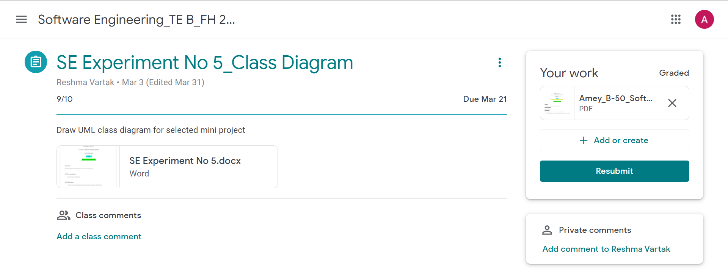

**Software Engineering Experiment 6**

**Marks: (9/10)**

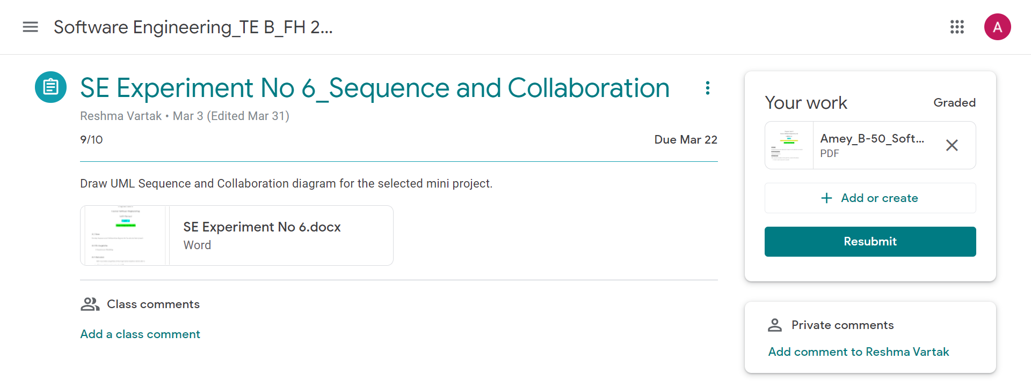

**Software Engineering Experiment 7**

**Marks: (9/10)**

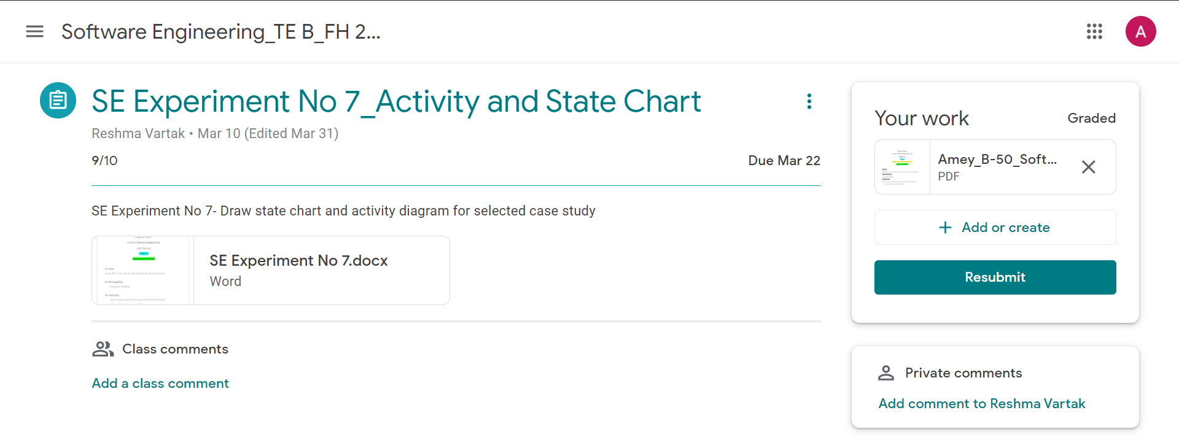

**Software Engineering Experiment 8**

**Marks: (9/10)**

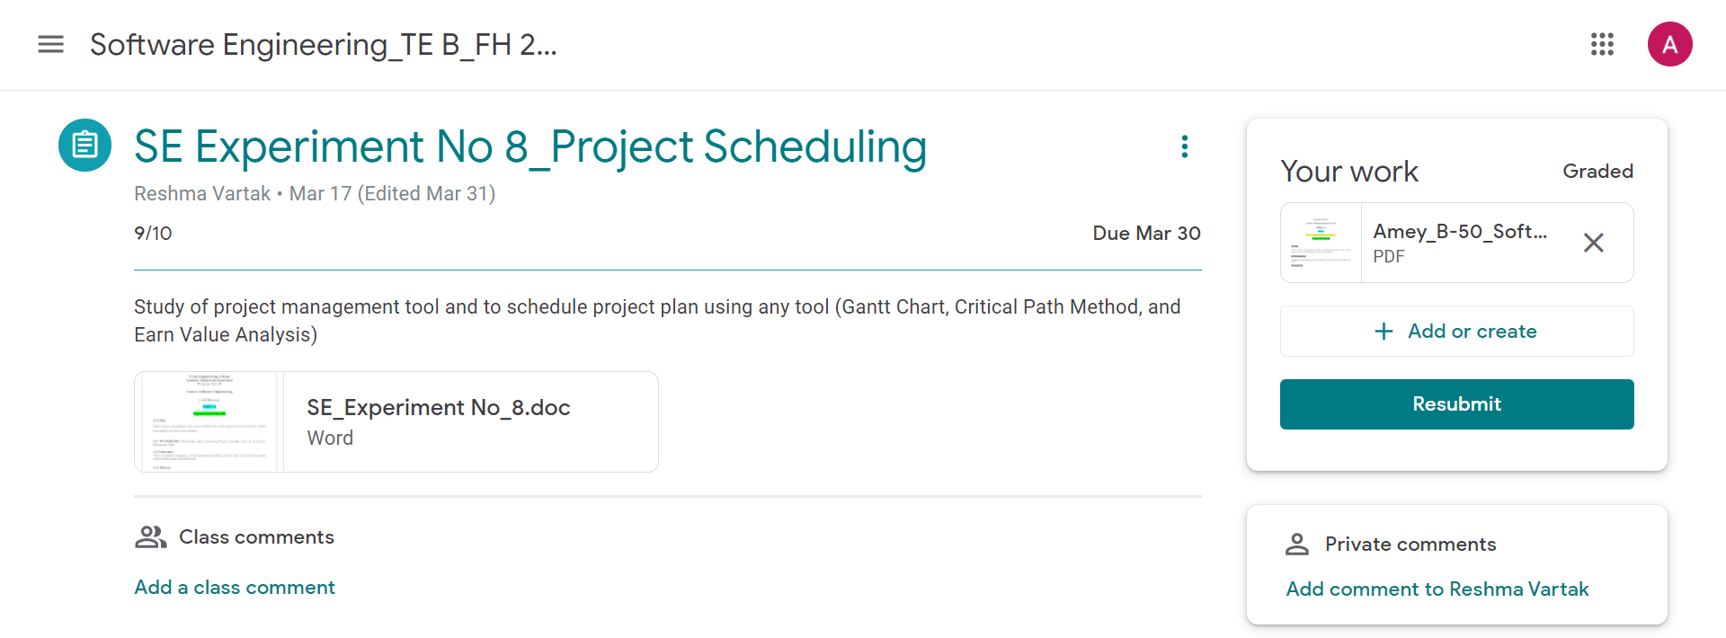

**Software Engineering Experiment 9**

**Marks: (10/10)**

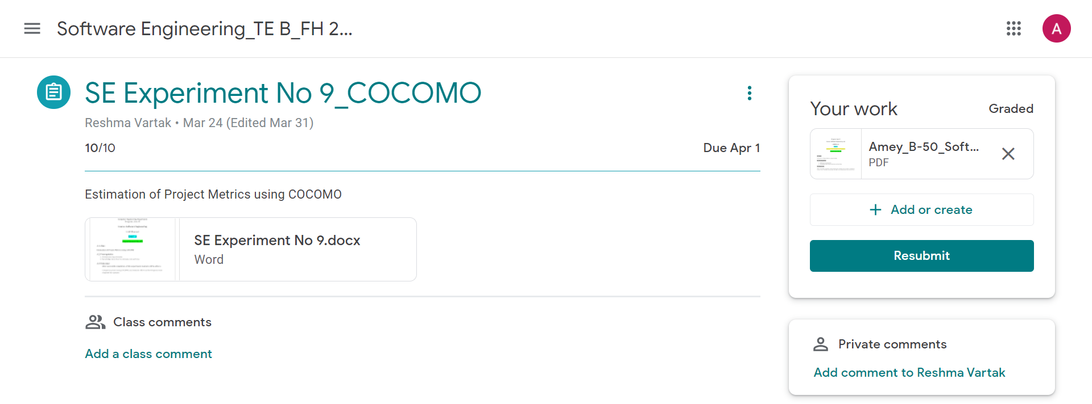

**Software Engineering Experiment 10**

**Marks: (9/10)**

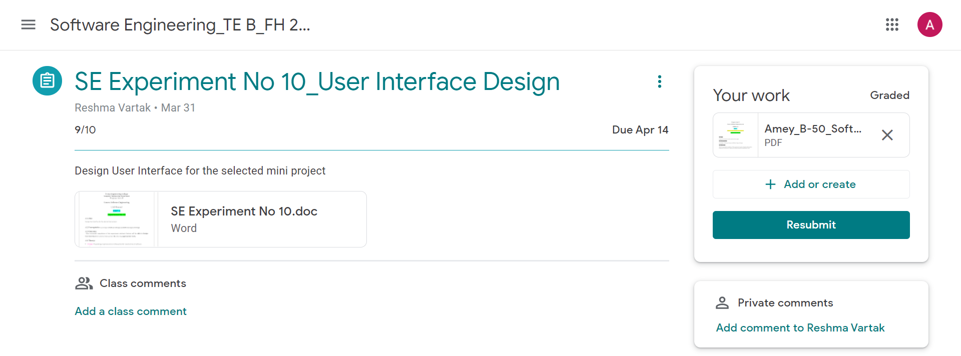

**Software Engineering Experiment 11**

**Marks: (9/10)**

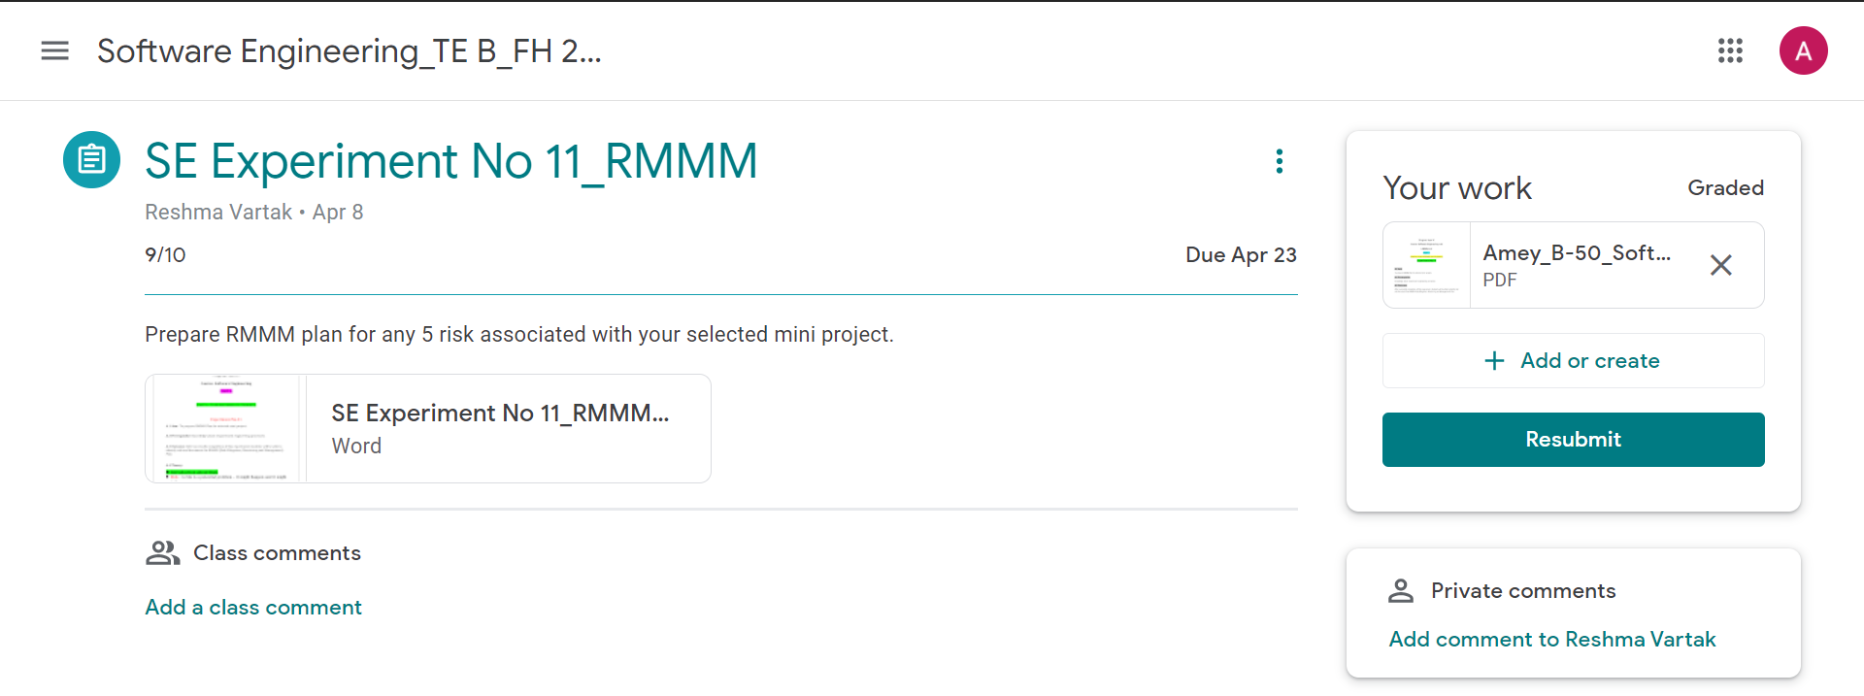

**Software Engineering Experiment 12**

**Marks: (9/10)**

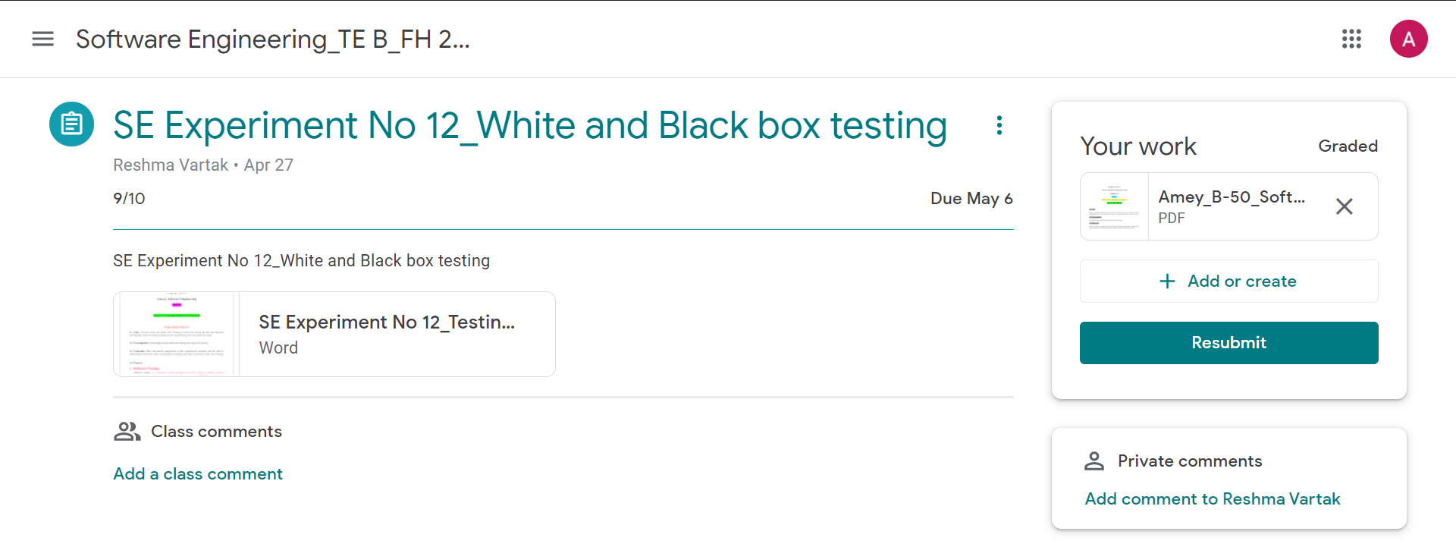

**Assignments**

**Software Engineering Assignment 1**

**Marks: (9/10)**

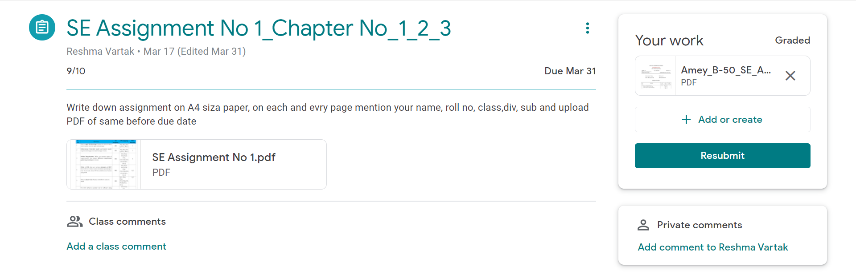

**Software Engineering Assignment 2**

**Marks: (10/10)**

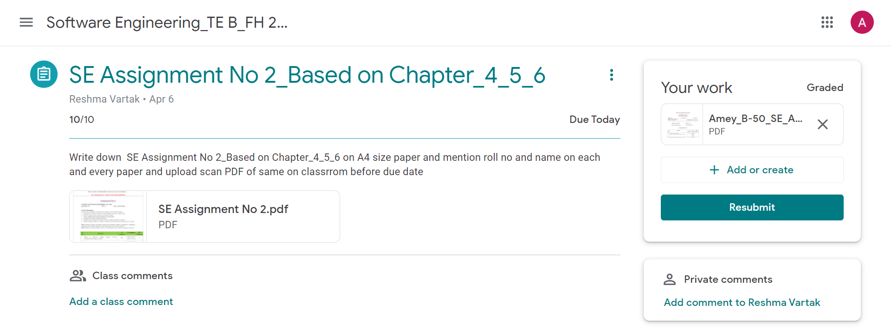

**Software Engineering Assignment 3**

**Marks: (9/10)**

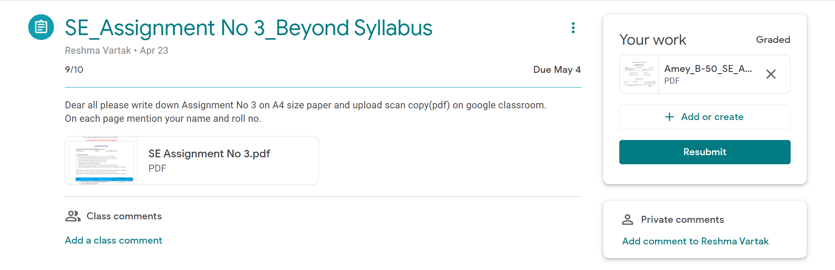

**Quizzes**

**Software Engineering Quiz 1**

**Marks: (10/10)**

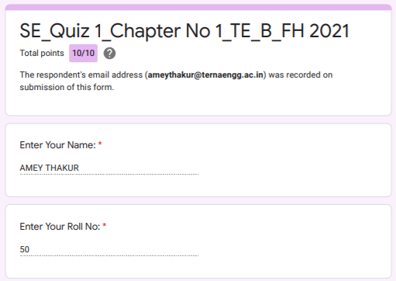

**Software Engineering Quiz 2**

**Marks: (10/10)**

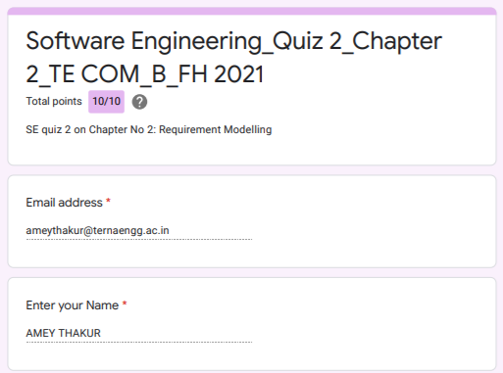

**Software Engineering Quiz 3**

**Marks: (10/10)**

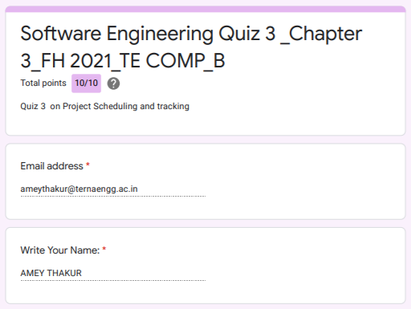

**Software Engineering Quiz 4**

**Marks: (10/10)**

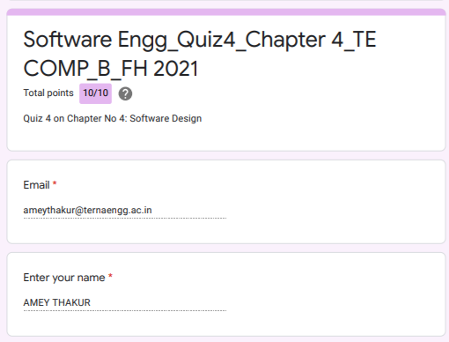

**Software Engineering Quiz 5**

**Marks: (10/10)**

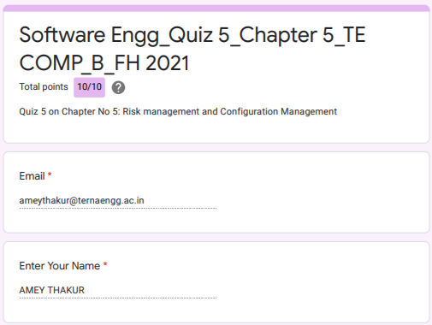

**Software Engineering Quiz 6**

**Marks: (10/10)**

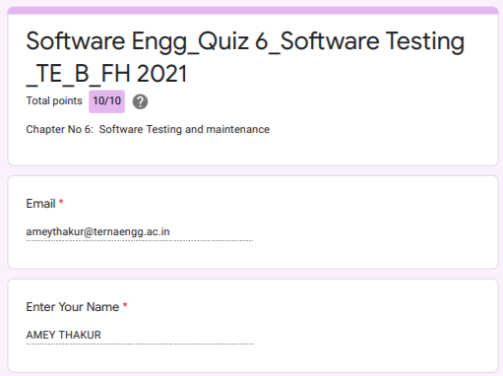

**IAT**

**Software Engineering IAT 1**

**Marks: (19/20)**

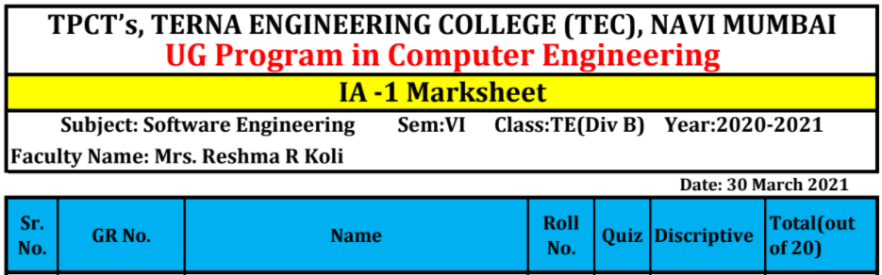

**IAT 1 Descriptive Answer Sheet**

**(First page attached)**

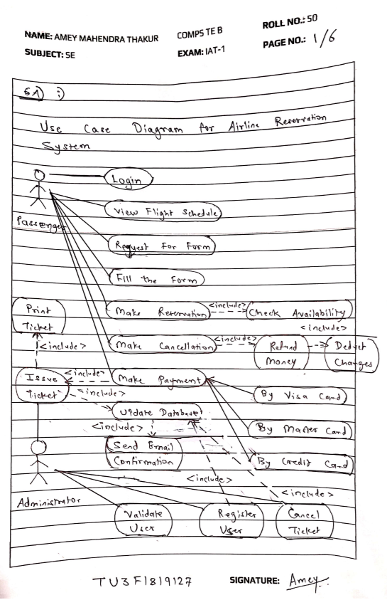

**Software Engineering IAT 2**

**Marks: Not Received**

**IAT 2 Descriptive Answer Sheet**

**(First page attached)**

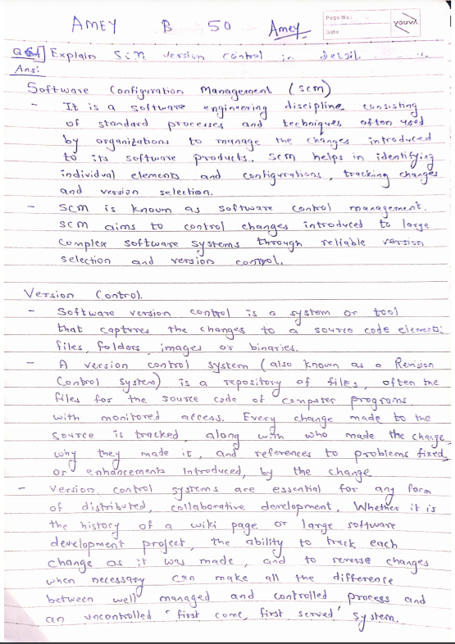

**Exit Survey**

**Software Engineering Course Exit survey**

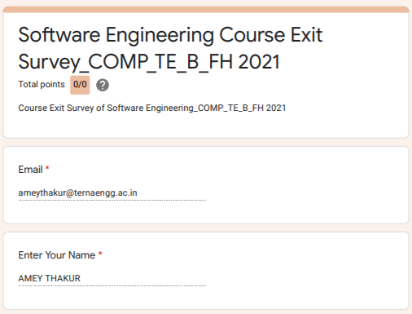

**Software Engineering Laboratory Exit Survey**

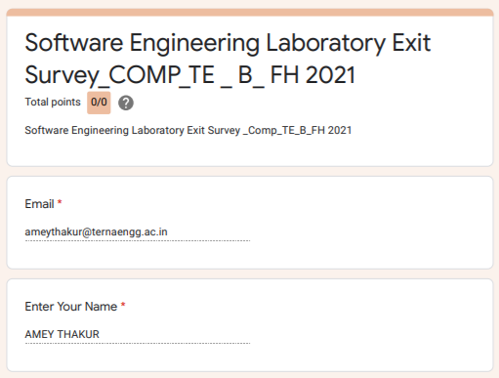

**Google Classroom Submission Report**

